**Spring 2019**

**CSE 5330 – Database Systems 1**

**Project 1 Phase 1**

**Conceptual Schema Database Schema**

**Project Members:**

Balaji Gurumoorthy – 1001680348

Goutami Padmanabhan – 1001669338

**Professor:** Bhanu Chaturvedi Jain

**Honor Code**

I pledge, on my honor, to uphold UT Arlington's tradition of academic integrity, a tradition that values hard work and honest effort in the pursuit of academic excellence.

I promise that I will submit only work that I personally create or that I contribute to group collaborations, and I will appropriately reference any work from other sources. I will follow the highest standards of integrity and uphold the spirit of the Honor Code.

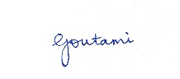



Balaji Gurumoorthy Goutami Padmanabhan

I pledge, on my honor, to uphold UT Arlington's tradition of academic integrity, a tradition that values hard work and honest effort in the pursuit of academic excellence.

**Enhanced Entity Relationship Diagram for the Database SOCCER:**

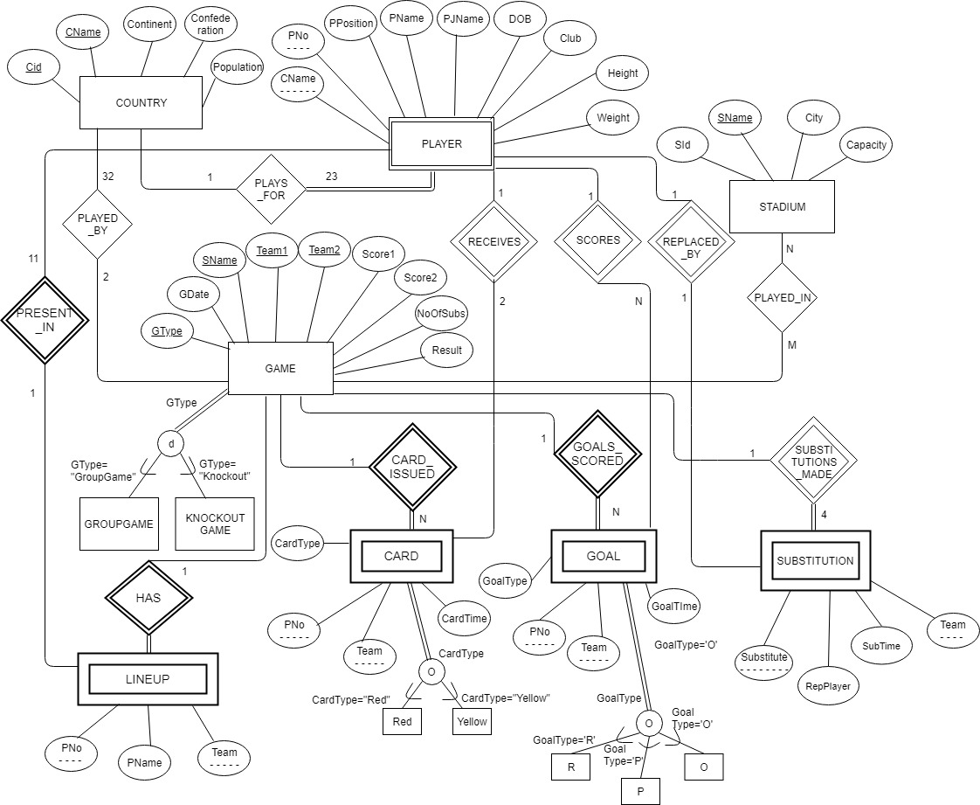

*Note: Since it is a conceptual design of the database we have not mentioned surrogate key GId as an attribute in the SOCCER database*

**Relational Schema for the above Enhanced Entity Relationship Diagram for the Project Soccer:**

COUNTRY

|  |  |  |  |  |
| --- | --- | --- | --- | --- |
| Cid | CName | Continent | Confederation | Population |

PLAYER

|  |  |  |  |  |  |  |  |  |
| --- | --- | --- | --- | --- | --- | --- | --- | --- |
| CName | PNo | PPosition | PName | PJName | DOB | Club | Height | Weight |

STADIUM

|  |  |  |  |
| --- | --- | --- | --- |
| Sid | SName | City | Capacity |

GAME

|  |  |  |  |  |  |  |  |  |  |
| --- | --- | --- | --- | --- | --- | --- | --- | --- | --- |
| GId | GType | GDate | SName | Team1 | Team2 | Score1 | Score2 | NoOfSubs | Result |

CARD

|  |  |  |  |  |
| --- | --- | --- | --- | --- |
| GId | PNo | Team | CardType | CardTime |

GOAL

|  |  |  |  |  |
| --- | --- | --- | --- | --- |
| GId | PNo | Team | GoalType | GoalTime |

SUBSTITUTION

|  |  |  |  |  |
| --- | --- | --- | --- | --- |
| GId | Substituite | SubTime | RepPlayer | Team |

LINEUP

|  |  |  |  |
| --- | --- | --- | --- |
| GId | PNo | PName | Team |

**Tables and Integrity Constraints in Relational Schema:**

**COUNTRY:**

|  |  |  |  |
| --- | --- | --- | --- |
| **Column Name** | **Description** | **Key Type** | **Reason** |
| Cid | Country Identification Number | Unique Key | For each COUNTRY a Unique Id will be assigned |
| CName | Country Name | Primary Key | Every COUNTRY will have a Unique Name and Country Name is referred by GAME & PLAYER tables for each Team and match |
| Continent | Continent Name |  | Continent to which the country belongs to |
| Confederation | Confederation Name |  | Tournament is divided into 6 confederations or groups based on the continent the team belong to |
| Population | Population of Country |  | Population of each country that plays |

**PLAYER:**

|  |  |  |  |
| --- | --- | --- | --- |
| **Column Name** | **Description** | **Key Type** | **Reason** |
| PNo | Player No | Partial Key | Each Player Of a country is assigned with a number from 1-23 and made as Partial Key as PLAYER is a weak entity |
| CName | Country Name | Foreign Key | Refers to Country Name (CName) defined in COUNTRY table which is a primary key. Underlined as PLAYER is a Weak Entity |
| PPosition | Player Position |  | Position of the player in a match like GK, DF, MF, FW |
| PName | Player Name |  | Name of the Player |
| PJName | Player Jersey Name |  | Name of the Player displayed in the Jersey |
| DOB | Date Of Birth |  | Birth date of the player |
| Club | Club |  | Club for which the player plays for |
| Height | Height |  | Height of each player |
| Weight | Weight |  | Weight of each player |

**STADIUM:**

|  |  |  |  |
| --- | --- | --- | --- |
| **Column Name** | **Description** | **Key Type** | **Reason** |
| SId | Stadium Identification Number | Unique Key | For each STADIUM a Unique Id will be assigned |
| SName | Stadium Name | Primary Key | Every Stadium will have a Unique Name and Stadium Name is referred by GAME for each match |
| City | City Name |  | Name of the City where the Stadium is located |
| Capacity | Stadium Capacity |  | Capacity of the Stadium or the maximum number of spectators the stadium can have |

**GAME:**

|  |  |  |  |
| --- | --- | --- | --- |
| **Column Name** | **Description** | **Key Type** | **Reason** |
| GId | Game ID | Primary Key | Each match will be assigned with a key value which will be referred by GAME, CARD, GOAL and SUBSTITUTION tables. |
| GType | Game Type | Unique key | Game type specifies whether it is a group game or a knockout game. It will have the values A, B, C, D, E, F, G, H, X, Q, S, L, T |
| GDate | Game Date |  | Date on which the match was played |
| SName | Stadium Name | Foreign Key | Refers to Stadium Name defined in STADIUM table |
| Team1 | Team 1 | Foreign Key | Refers to Country Name (CName) defined in COUNTRY table. First team that is played the match |
| Team2 | Team 2 | Foreign Key | Refers to Country Name (CName) defined in COUNTRY table. Second team that played the match |
| Score1 | Team 1 Score |  | Score of Team 1 will be stored here |
| Score2 | Team 2 Score |  | Score of Team 2 will be stored here |
| NoOfSubs | No of Substitutes |  | Total No of Substitutions made in a match |
| Result | Result |  | Result of the match. Win/Lose/Draw (W/L/D) |

**SUBSTITUTION:**

|  |  |  |  |
| --- | --- | --- | --- |
| **Column Name** | **Description** | **Key Type** | **Reason** |
| GId | Game ID | Foreign Key | Refers to GId of each match defined in GAME table |
| Substitute | Substitution Player Number | Foreign key and Partial key | Player number of the player who replaces another player |
| Team | Team name | Foreign key and Partial key | Name of the team in GAME table |
| SubTime | Substitution Time |  | Time at which player substitution was made |
| RepPlayer | Player Replaced |  | Name of Player Who got Replaced by Another Player |

**GOAL:**

|  |  |  |  |
| --- | --- | --- | --- |
| **Column Name** | **Description** | **Key Type** | **Reason** |
| GId | Game ID | Foreign Key | Refers to GId of each match defined in GAME table. |
| PNo | Player Number | Foreign key and Partial key | Player Number of the Player who scored a Goal |
| Team | Country Name | Foreign key and Partial key | Name of the country that scored the goal |
| GoalType | Goal Type |  | Goal Type can be Regular/Own/Penalty (R/O/P) |
| GoalTime | Time when Goal scored |  | Time when the player scored the goal |

**CARD:**

|  |  |  |  |
| --- | --- | --- | --- |
| **Column Name** | **Description** | **Key Type** | **Reason** |
| GId | Game ID | Foreign Key | Refers to GId of each match defined in GAME table. |
| PNo | Player No | Foreign key and Partial key | Player Number of the player who received a card |
| Team | Country Name | Foreign key and Partial key | Name of the country that received the card |
| CardType | Type of Card Issued |  | Type of Card isused to a player during a match (Red or Yellow) |
| CardTime | Time of Card Given |  | Time when a card was given to a player during a match |

**LINEUP:**

|  |  |  |  |
| --- | --- | --- | --- |
| **Column Name** | **Description** | **Key Type** | **Reason** |
| GId | Game ID | Foreign Key | Refers to GId of each match defined in GAME table. |
| PNo | Player No | Foreign key and Partial key | Player Number of the player who received a card |
| Team | Country Name | Foreign key and Partial key | Name of the country that received the card |
| PName | Player Name |  | Name of the player who played the game |

**Proofs of executing create statements**

SOCCER database

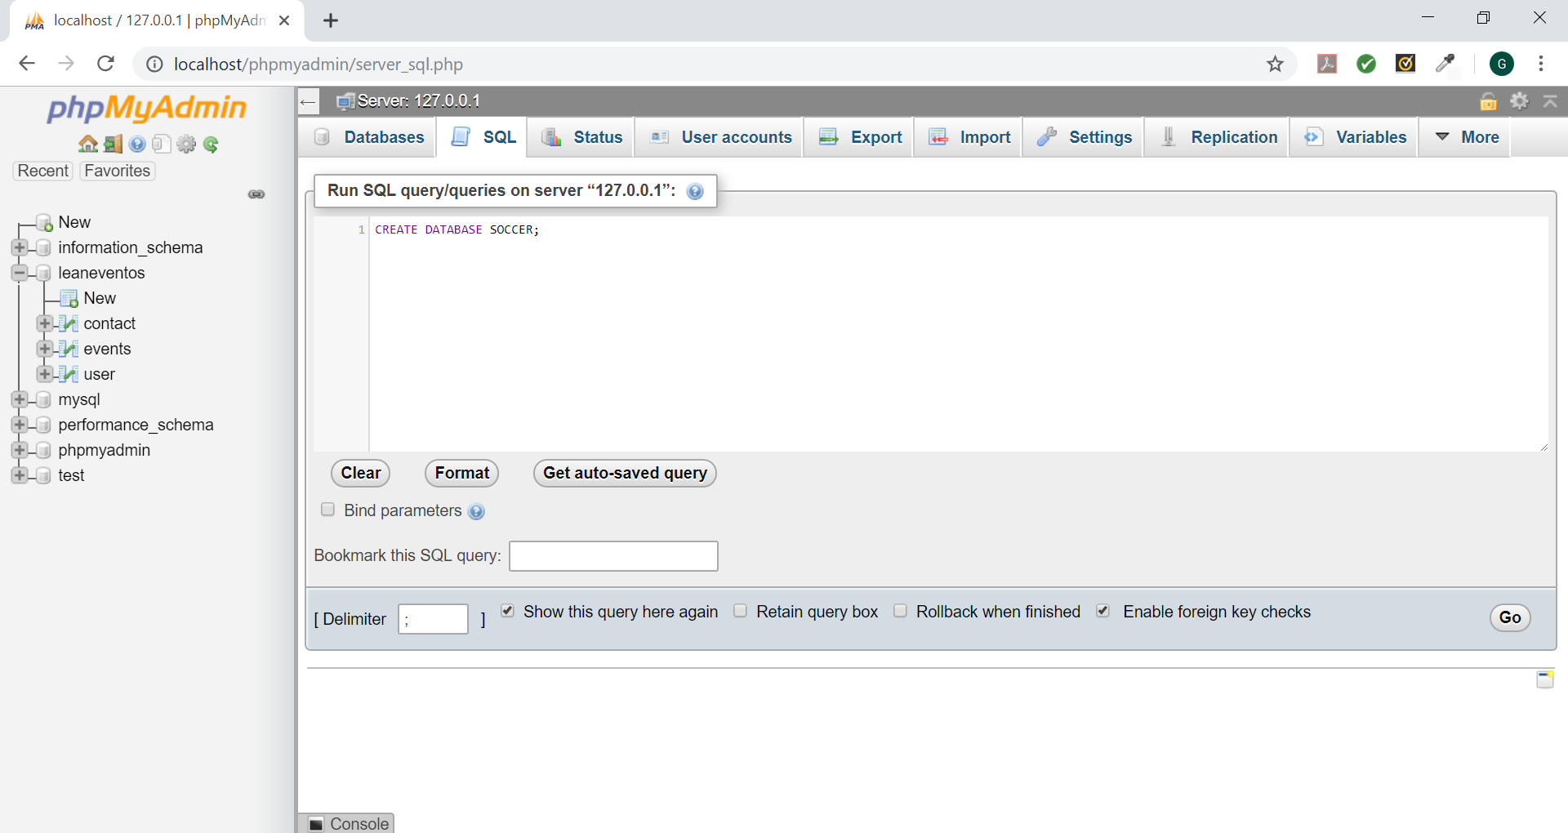

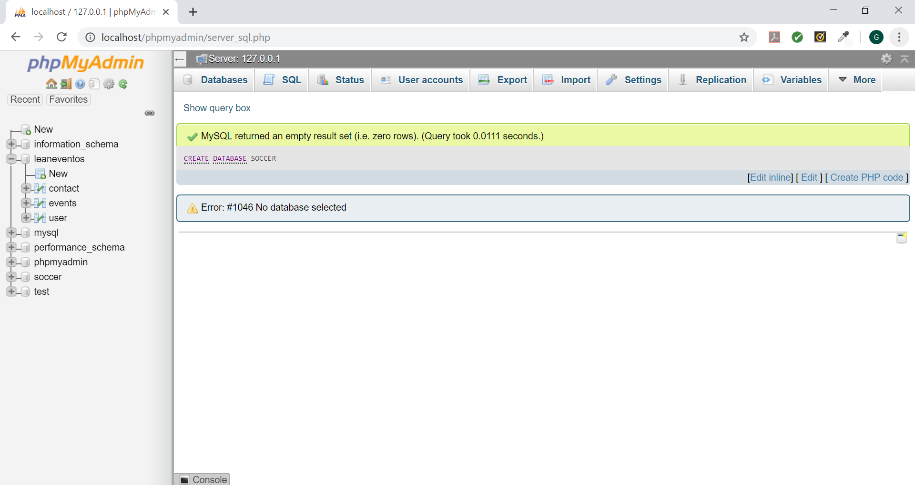

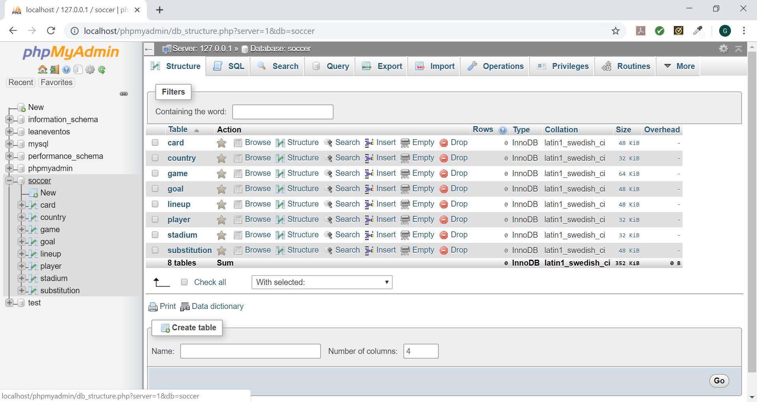

Query used:

CREATE DATABASE SOCCER;

COUNTRY

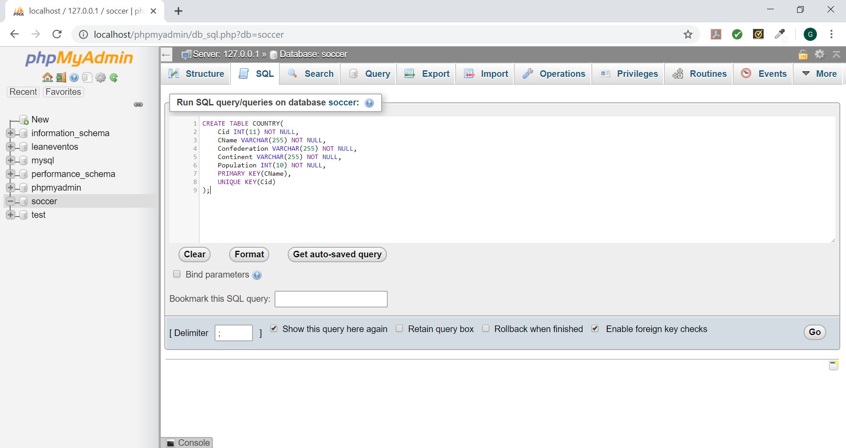

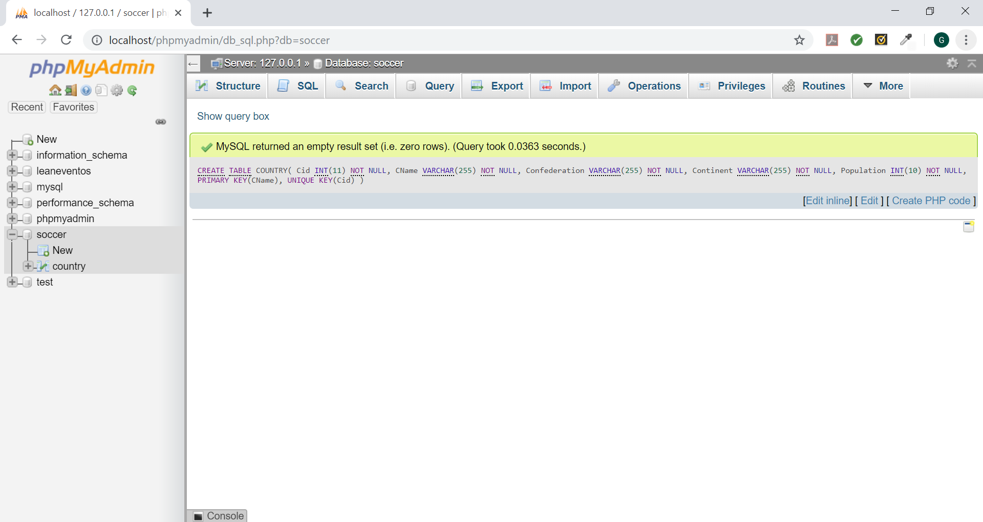

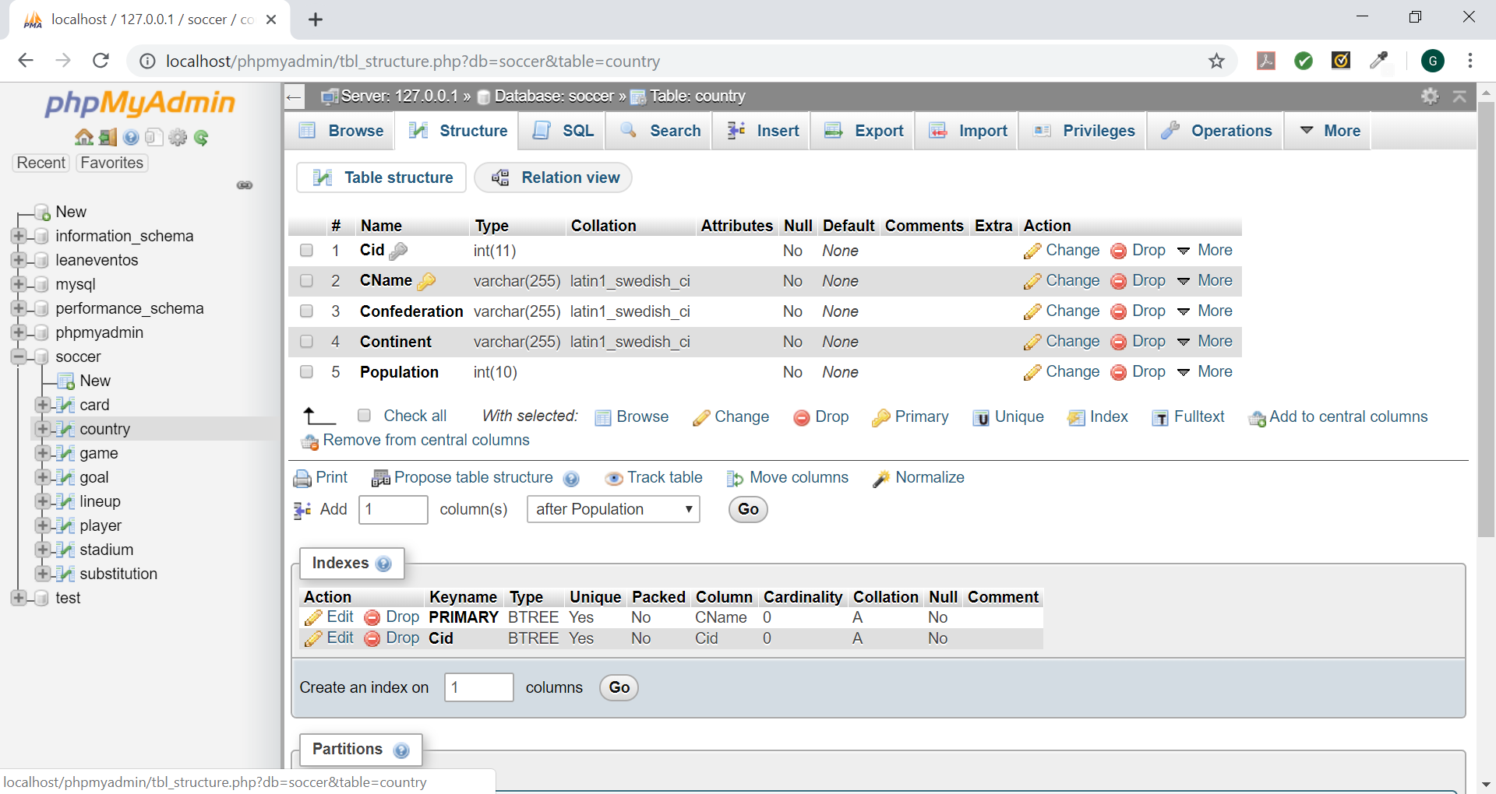

Query used:

CREATE TABLE COUNTRY(

Cid INT(11) NOT NULL,

CName VARCHAR(255) NOT NULL,

Confederation VARCHAR(255) NOT NULL,

Continent VARCHAR(255) NOT NULL,

Population INT(10) NOT NULL,

PRIMARY KEY(CName),

UNIQUE KEY(Cid)

);

PLAYER

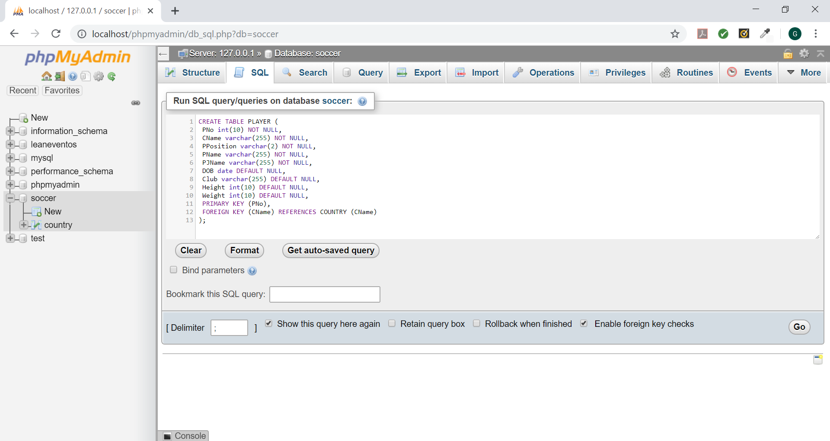

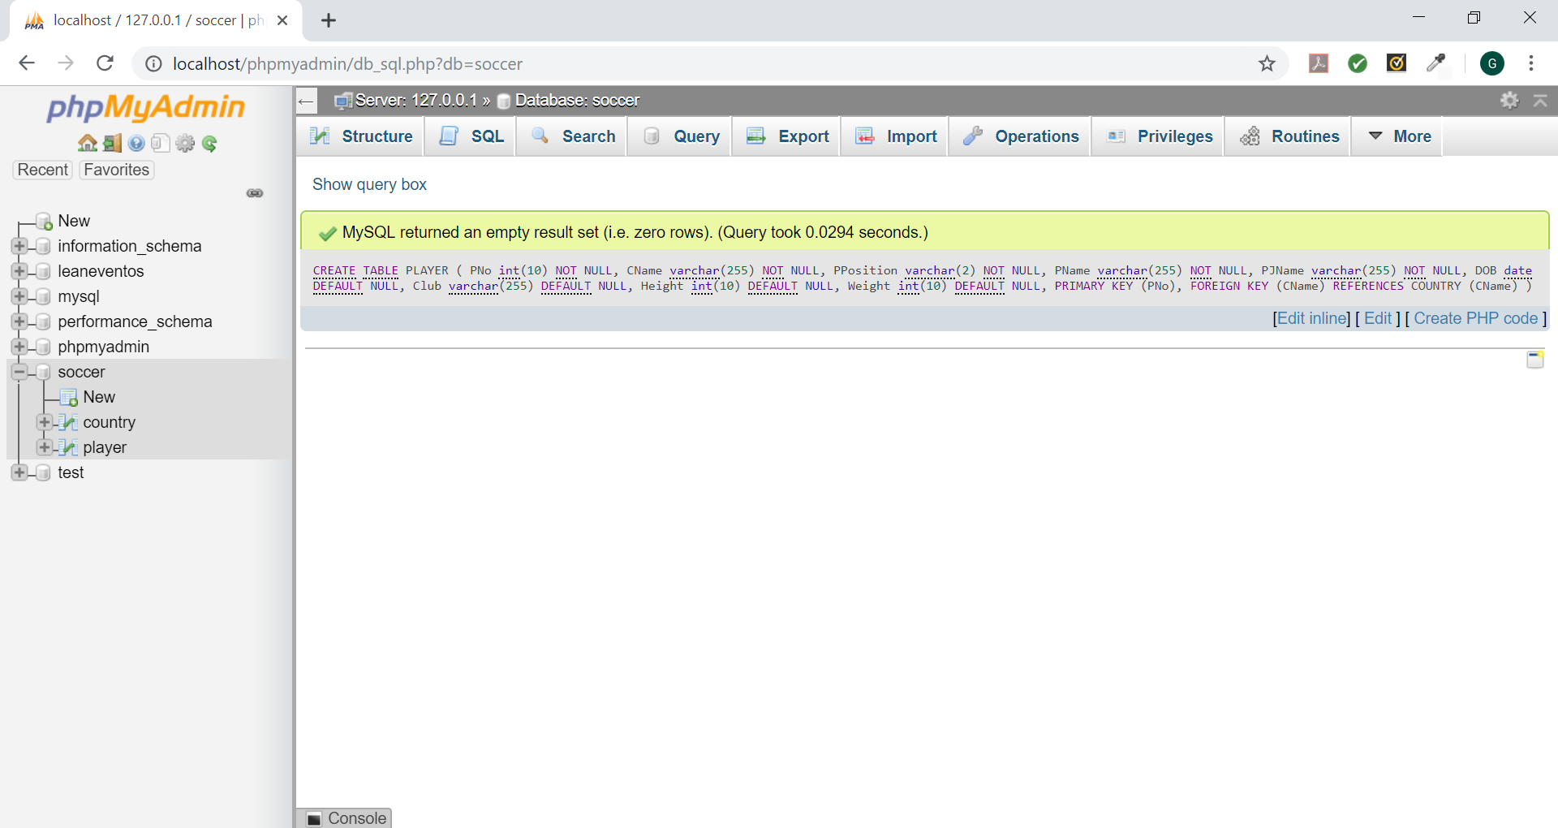

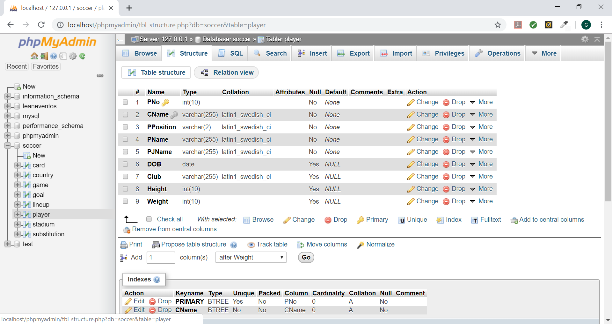

Query used:

CREATE TABLE PLAYER (

PNo int(10) NOT NULL,

CName varchar(255) NOT NULL,

PPosition varchar(2) NOT NULL,

PName varchar(255) NOT NULL,

PJName varchar(255) NOT NULL,

DOB date DEFAULT NULL,

Club varchar(255) DEFAULT NULL,

Height int(10) DEFAULT NULL,

Weight int(10) DEFAULT NULL,

PRIMARY KEY (PNo),

FOREIGN KEY (CName) REFERENCES COUNTRY (CName)

);

STADIUM

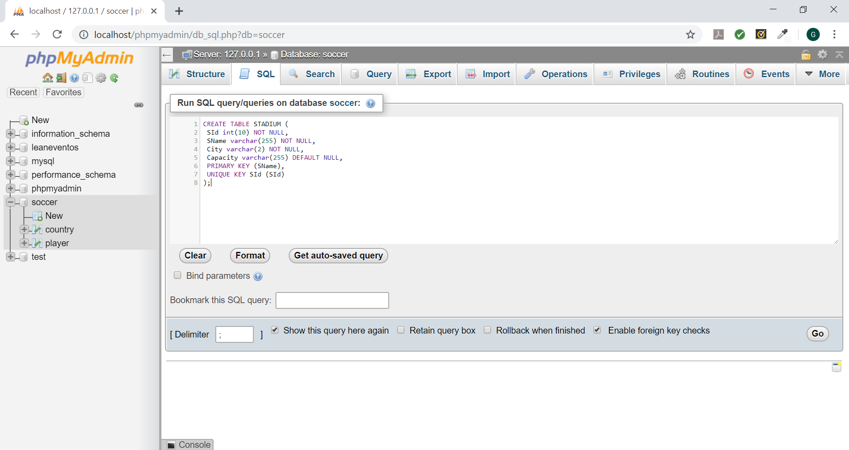

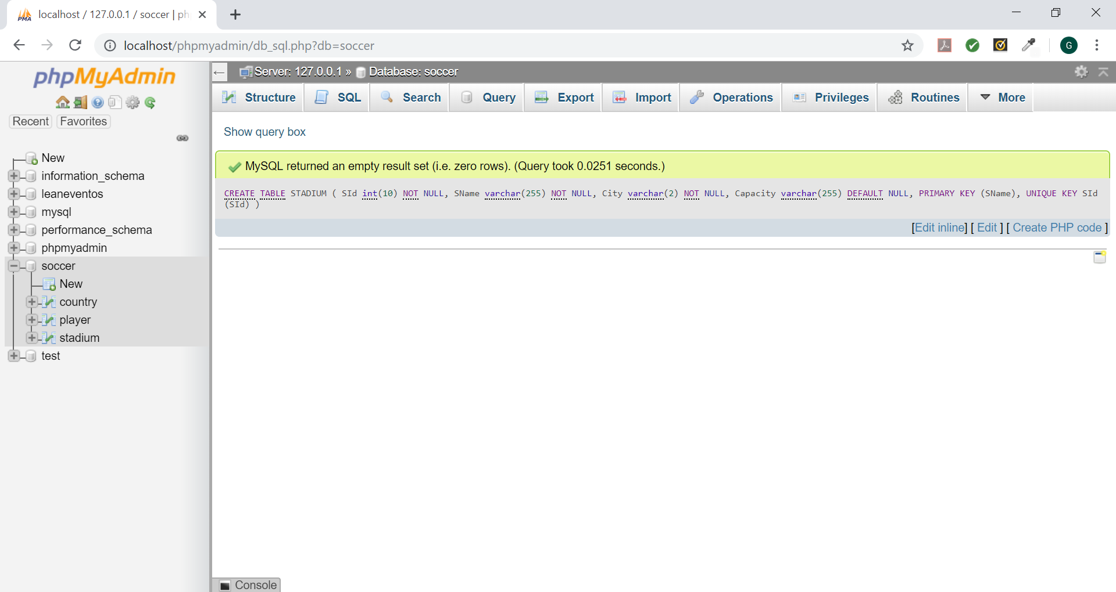

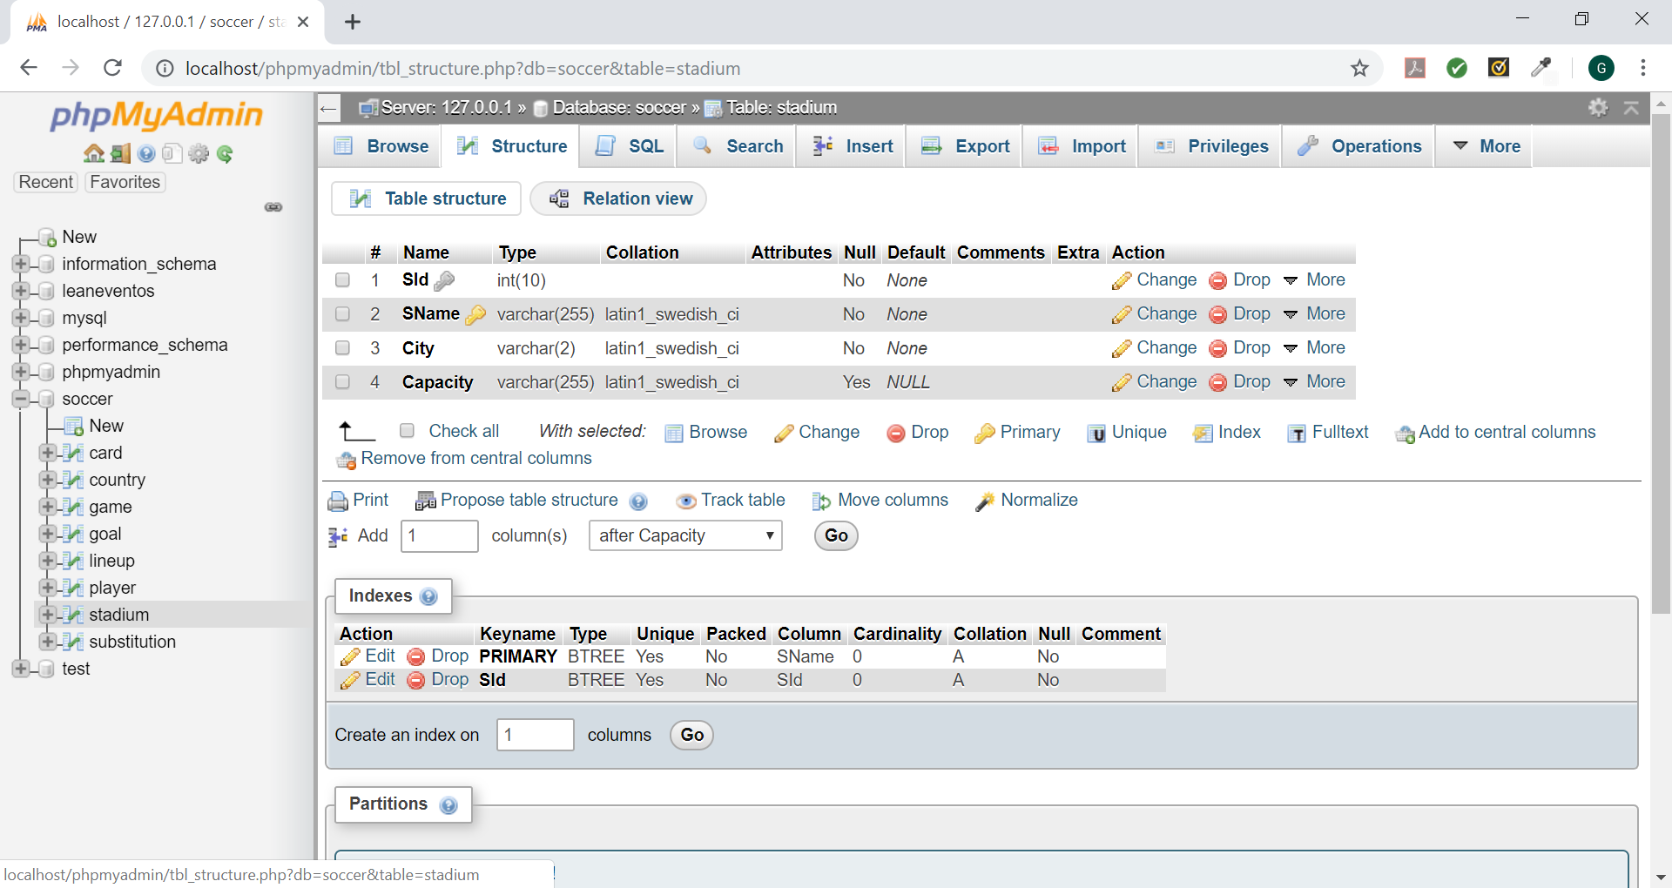

Query used:

CREATE TABLE STADIUM (

SId int(10) NOT NULL,

SName varchar(255) NOT NULL,

City varchar(2) NOT NULL,

Capacity varchar(255) DEFAULT NULL,

PRIMARY KEY (SName),

UNIQUE KEY SId (SId)

);

GAME

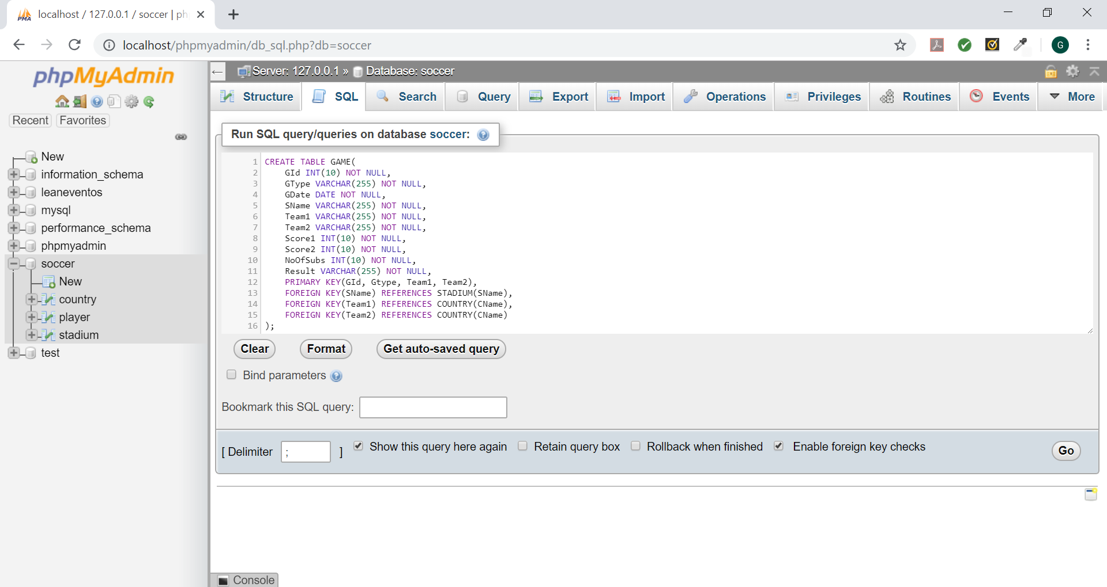

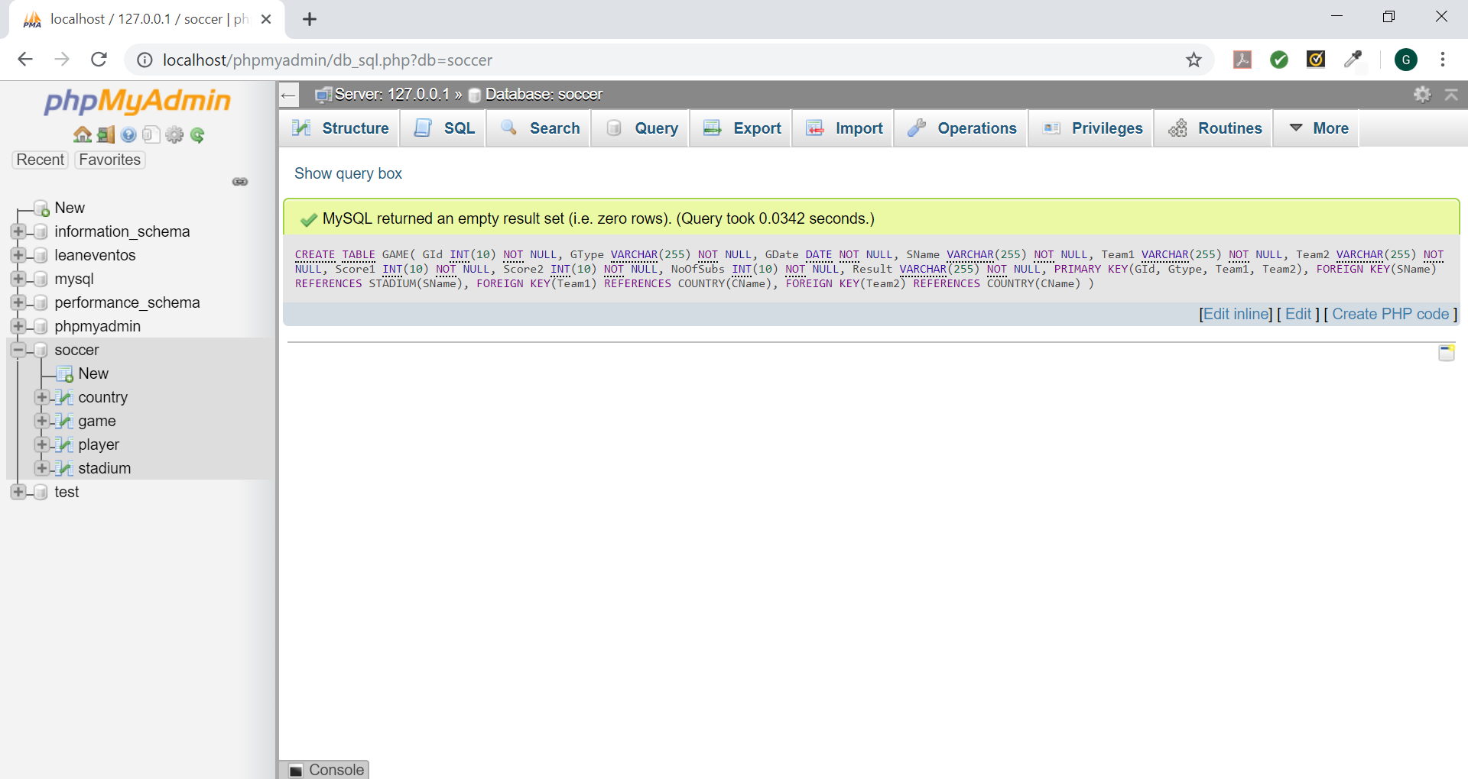

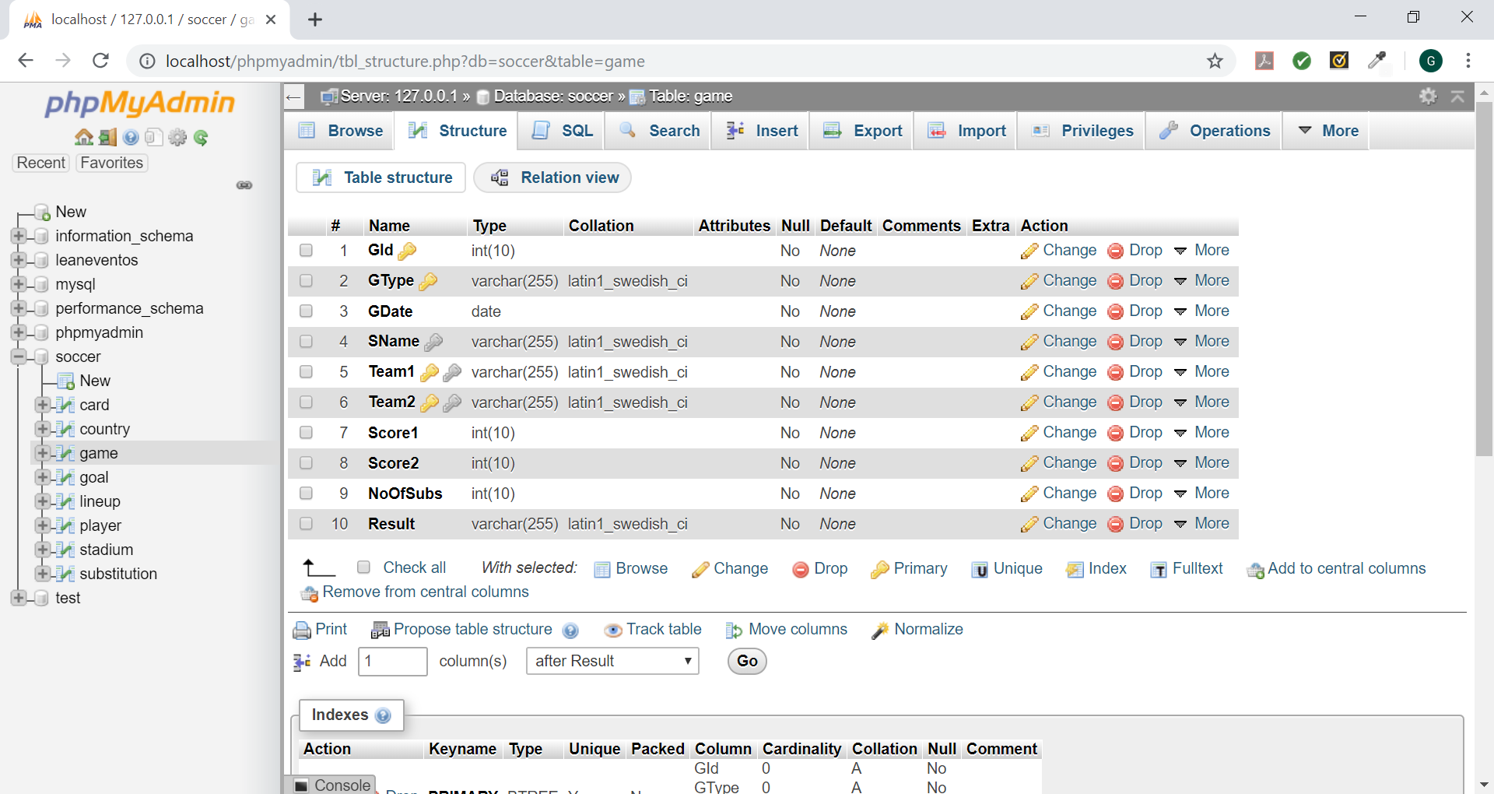

Query used:

CREATE TABLE GAME (

GId int(10) NOT NULL,

GType varchar(255) NOT NULL,

GDate date NOT NULL,

SName varchar(255) NOT NULL,

Team1 varchar(255) NOT NULL,

Team2 varchar(255) NOT NULL,

Score1 int(10) NOT NULL,

Score2 int(10) NOT NULL,

NoOfSubs int(10) NOT NULL,

Result varchar(255) NOT NULL,

PRIMARY KEY (GId,Gtype,Team1,Team2),

FOREIGN KEY (SName) REFERENCES STADIUM (SName),

FOREIGN KEY (Team1) REFERENCES COUNTRY (CName),

FOREIGN KEY (Team2) REFERENCES COUNTRY (CName)

);

CARD

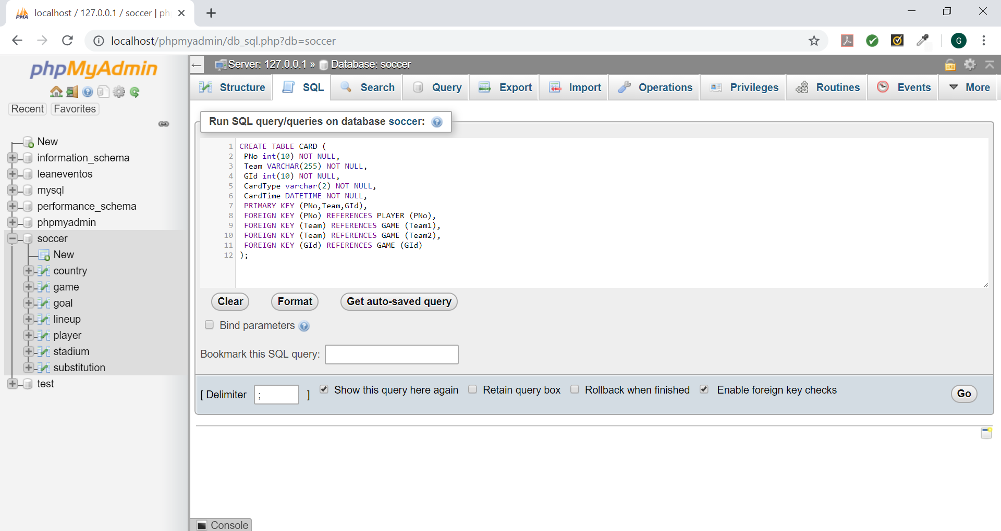

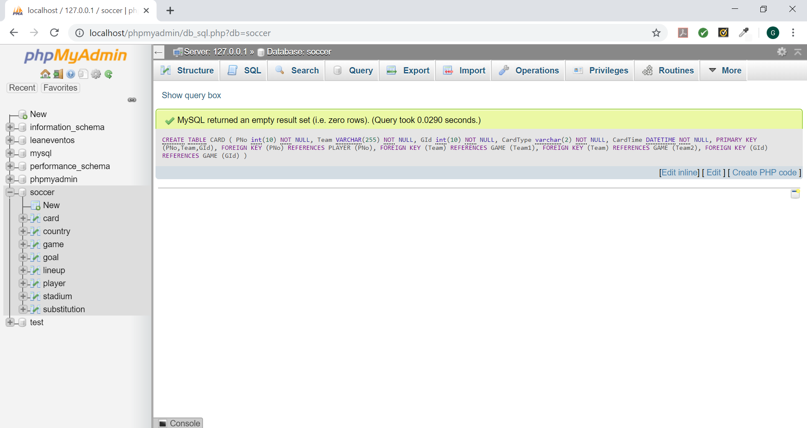

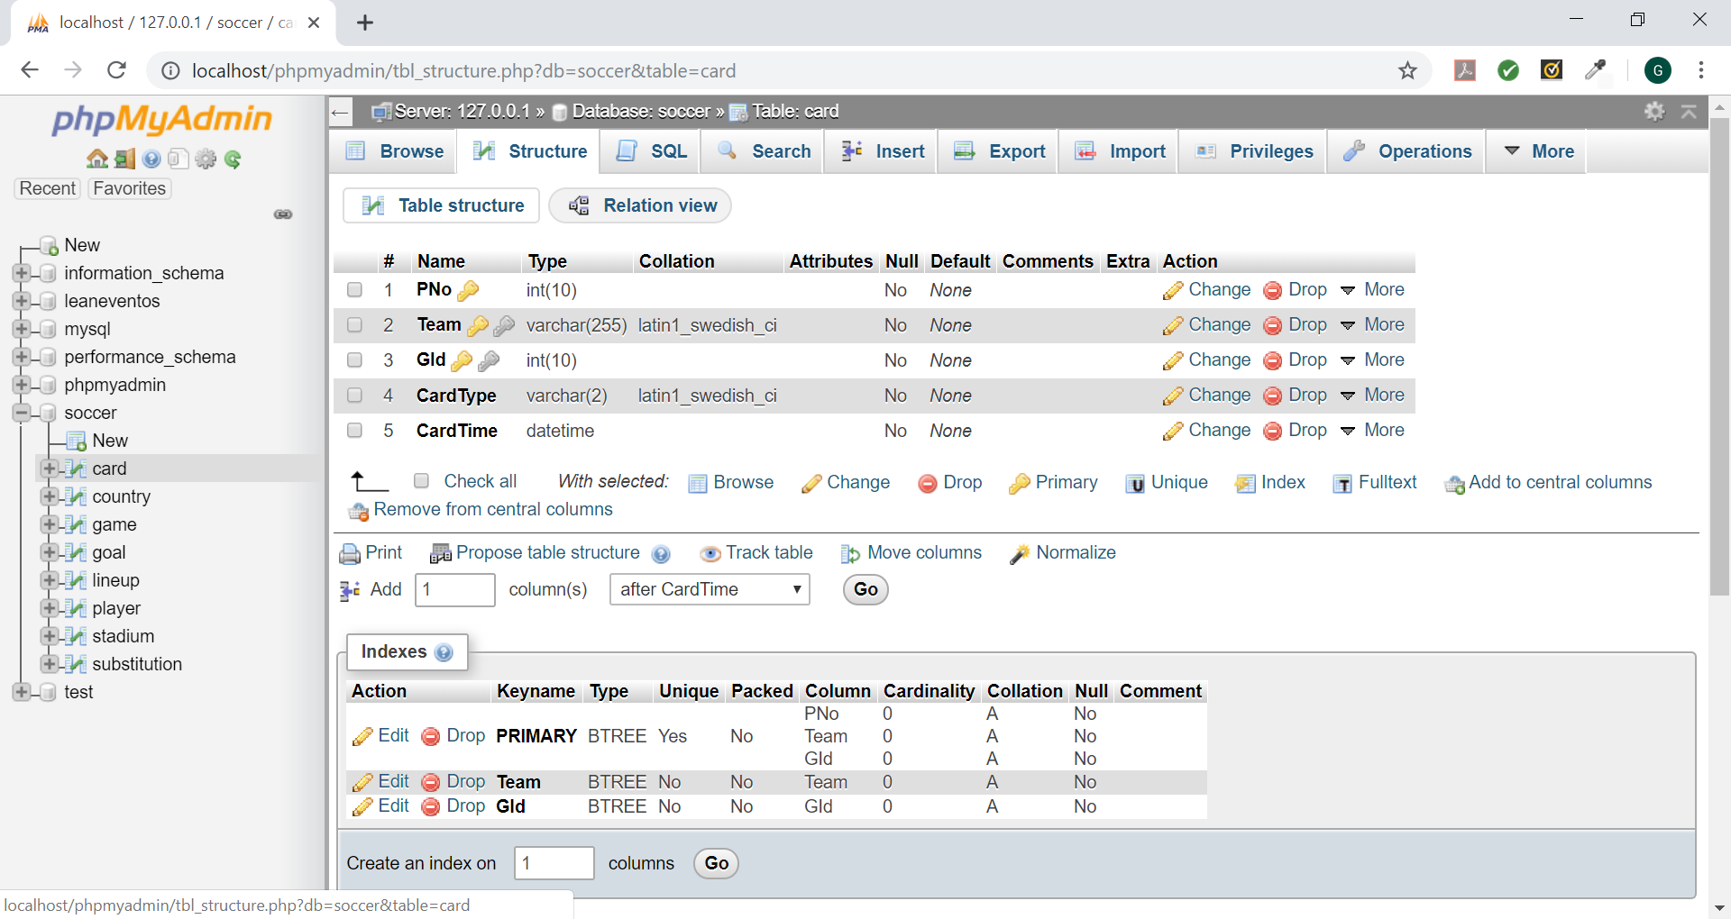

Query used:

CREATE TABLE CARD (

PNo int(10) NOT NULL,

Team VARCHAR(255) NOT NULL,

GId int(10) NOT NULL,

CardType varchar(2) NOT NULL,

CardTime DATETIME NOT NULL,

PRIMARY KEY (PNo,Team,GId),

FOREIGN KEY (PNo) REFERENCES PLAYER (PNo),

FOREIGN KEY (Team) REFERENCES GAME (Team1),

FOREIGN KEY (Team) REFERENCES GAME (Team2),

FOREIGN KEY (GId) REFERENCES GAME (GId)

);

GOAL

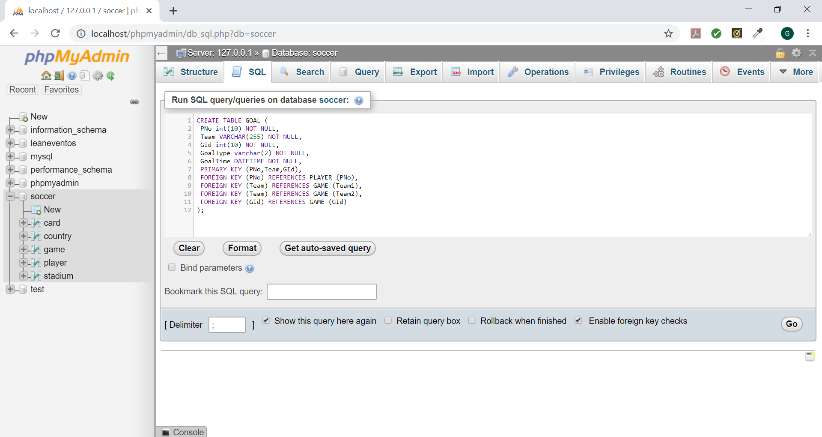

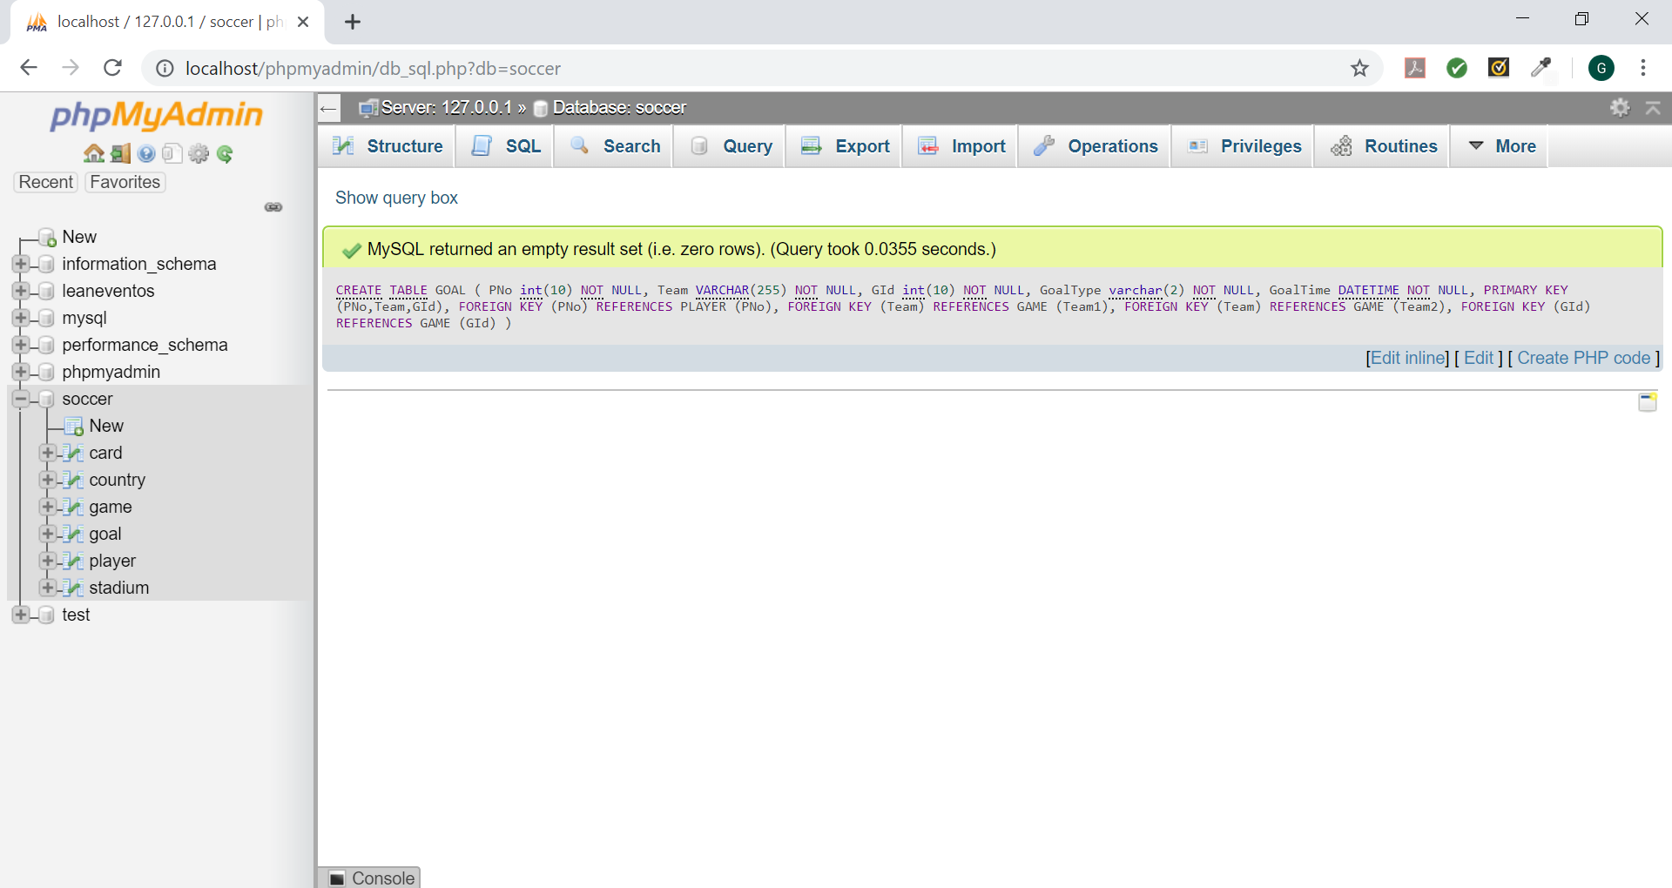

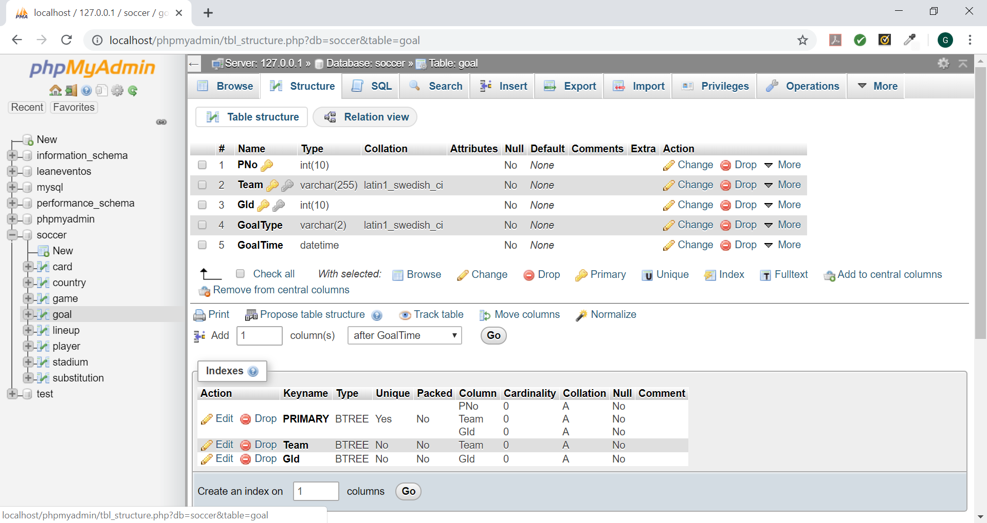

Query used:

CREATE TABLE GOAL (

PNo int(10) NOT NULL,

Team VARCHAR(255) NOT NULL,

GId int(10) NOT NULL,

GoalType varchar(2) NOT NULL,

GoalTime DATETIME NOT NULL,

PRIMARY KEY (PNo,Team,GId),

FOREIGN KEY (PNo) REFERENCES PLAYER (PNo),

FOREIGN KEY (Team) REFERENCES GAME (Team1),

FOREIGN KEY (Team) REFERENCES GAME (Team2),

FOREIGN KEY (GId) REFERENCES GAME (GId)

);

SUBSTITUTION

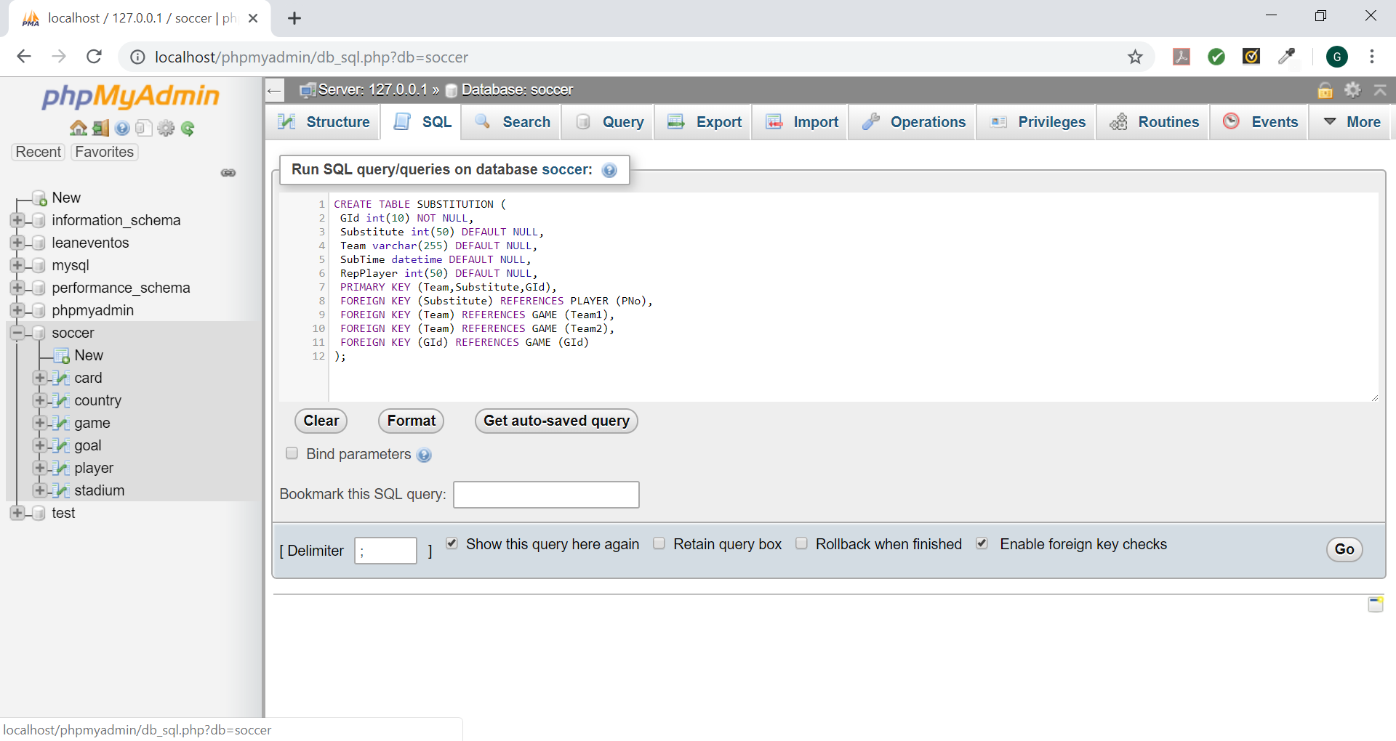

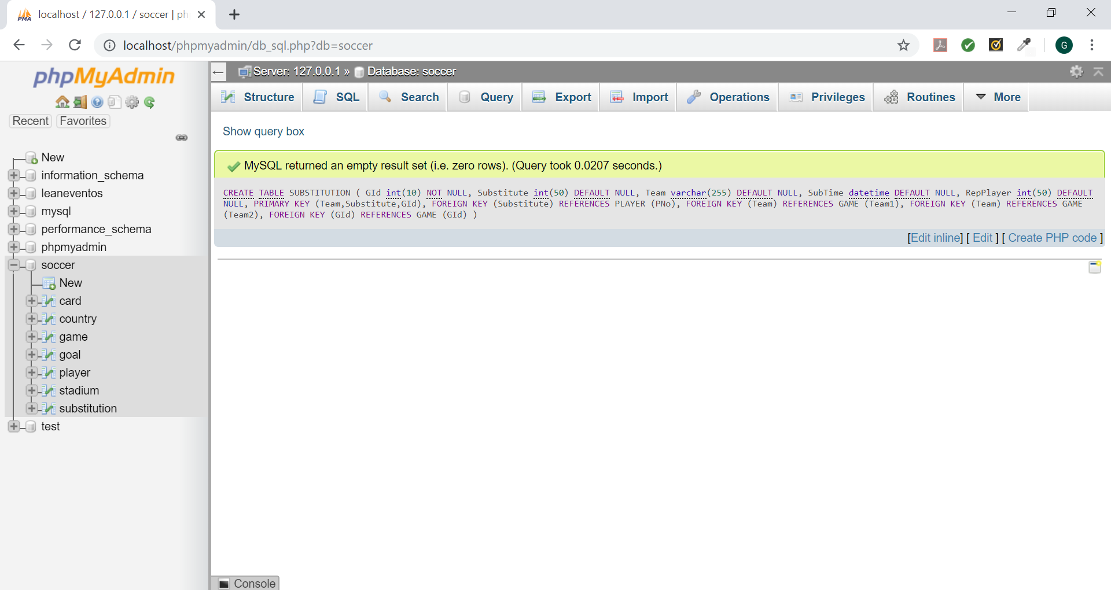

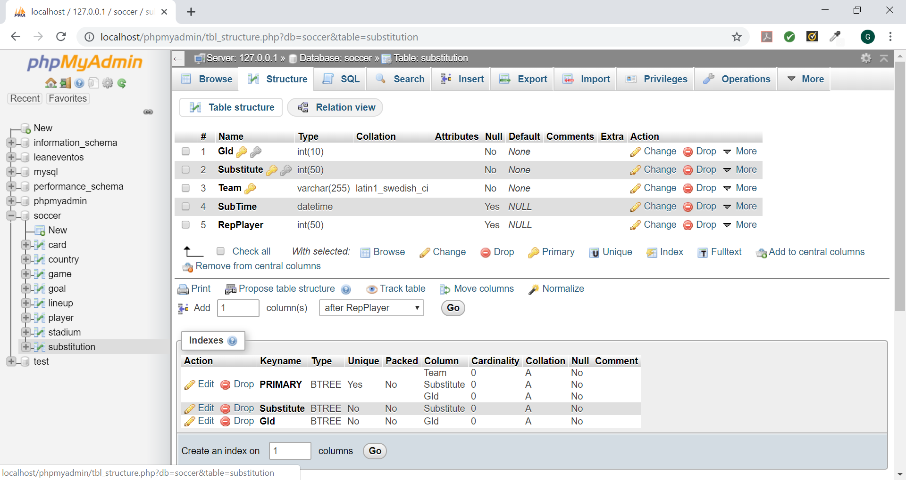

Query used:

CREATE TABLE SUBSTITUTION (

GId int(10) NOT NULL,

Substitute int(50) DEFAULT NULL,

Team varchar(255) DEFAULT NULL,

SubTime datetime DEFAULT NULL,

RepPlayer int(50) DEFAULT NULL,

PRIMARY KEY (Team,Substitute,GId),

FOREIGN KEY (Substitute) REFERENCES PLAYER (PNo),

FOREIGN KEY (Team) REFERENCES GAME (Team1),

FOREIGN KEY (Team) REFERENCES GAME (Team2),

FOREIGN KEY (GId) REFERENCES GAME (GId)

);

LINEUP

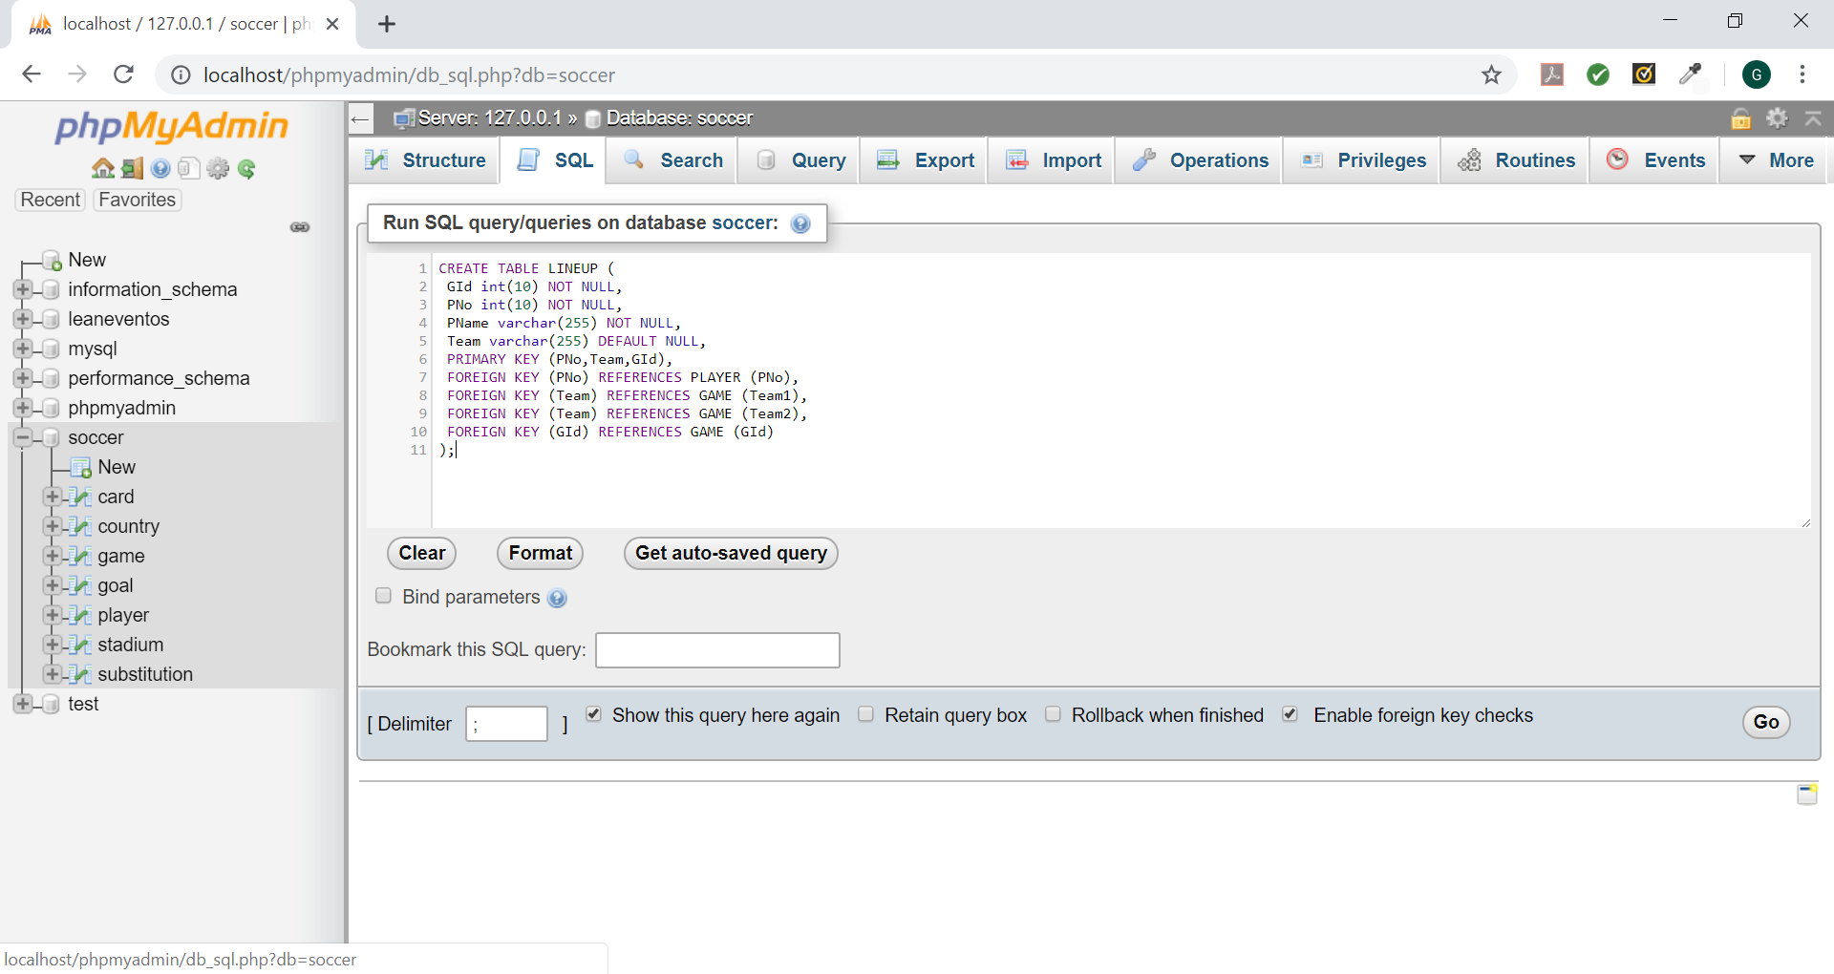

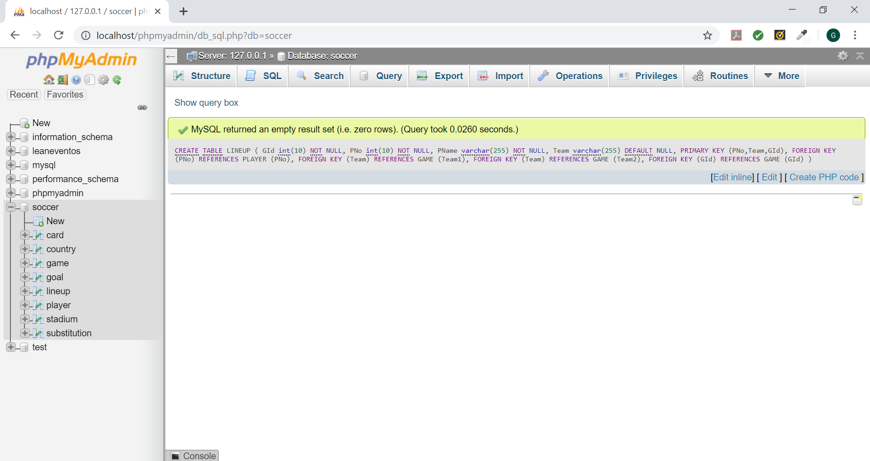

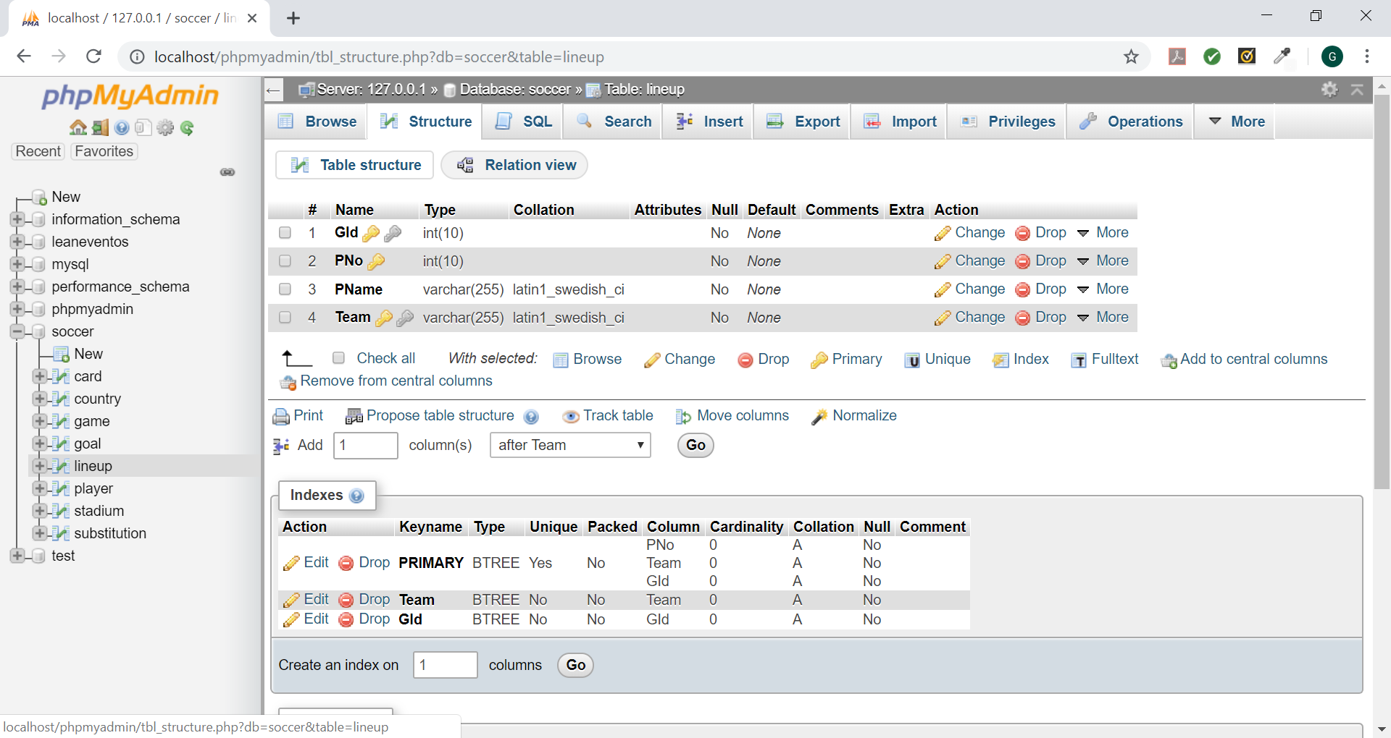

Query used:

CREATE TABLE LINEUP (

GId int(10) NOT NULL,

PNo int(10) NOT NULL,

PName varchar(255) NOT NULL,

Team varchar(255) DEFAULT NULL,

PRIMARY KEY (PNo,Team,GId),

FOREIGN KEY (PNo) REFERENCES PLAYER (PNo),

FOREIGN KEY (Team) REFERENCES GAME (Team1),

FOREIGN KEY (Team) REFERENCES GAME (Team2),

FOREIGN KEY (GId) REFERENCES GAME (GId)

);